MUDDYWATERBOATSR
MUDDYWATERBOATS.COM
1236 W Wisconsin Ave. Appleton, WI. 54914
920-731-4841—Fax 920-738-9494
E-mail: duckskiffs@gmail.com
WWA State Sponsor 2016.
Only (1) Teal or (1) Bluebill skiff per Chapter.
For Banquet Raffles Only.
BLUE BILL
Double End Skiff 14’ x 31”
Approx 70#
$599

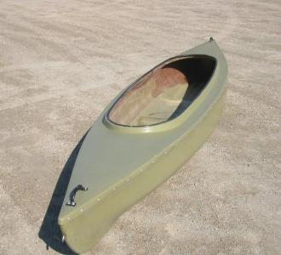
TEAL
Double End Skiff 10’ x 39”
Approx 60#
$499

