Waterfowl Stamp Fee Supports Critical Breeding Habitat
Small, often privately-owned wetlands are important to Wisconsin’s duck breeding (and hunting) success
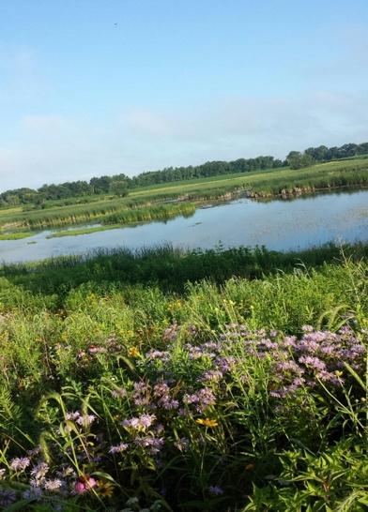
Every year, the state’s 65,000 waterfowlers purchase a $7 Wisconsin Waterfowl Stamp, which provides funding dedicated to wetland habitat and for producing waterfowl and ecologically related species of wildlife--67% here in Wisconsin and 33% in waterfowl production areas in Canada.

While the vast majority of these “duck stamp” funds are used to restore or maintain wetlands on which public hunting is permitted, between 15 - 20% of the funds are used to encourage Wisconsin’s private wetland owners to restore their wetlands which are critical to waterfowl breeding success.

Some people don’t understand why hunters would support using these funds to restore private wetlands on which they cannot hunt. Here’s why.

Wisconsin waterfowlers know:
- Only a small percentage (15-20%) of duck stamp funds go to private wetland restoration.
  - Public access is weighted as an important factor in the project approval process that results in most funds going towards publicly accessible wetlands.
But Ignoring private wetlands ultimately hurts Wisconsin’s 65,000 duck hunters.
  - Wisconsin is considered a “waterfowl production state”, producing most of the ducks harvested by state waterfowlers.
  - Most Wisconsin wetlands are privately held:
    - 75% of all Wisconsin wetlands are in private hands, and
    - 85% of the state’s restorable wetlands are on private lands.
  - Small wetlands that are typically found on private land are—acre-for-acre—more productive than larger wetlands for waterfowl nesting and brood-rearing.
  - Ducklings grow up. They fly off the property on which they were hatched in the spring, allowing for fall hunter success in other areas.
  - Hunter satisfaction is directly tied to number of ducks available in the hunting season.
Connecting these “dots” is easy—private wetlands disproportionately produce waterfowl in the Spring that are important to duck hunter satisfaction in the Fall.
- Even so, there’s no “free lunch” for the private landowner.
  - Landowners must have some ‘skin in the game’, using their own funds together with duck stamp (and other) funding to implement these small projects.
  - But without the enabling effect of duck stamp monies, many landowners would not undertake the wetland projects that benefit their communities and all of Wisconsin’s waterfowlers.
WWA independently raises funds, that are used with landowner funds, and duck stamp funding (and other local, state and federal grants), to focus on these small-scale projects that are important to Wisconsin waterfowl breeding success and duck hunter satisfaction with their season.
Wisconsin duck hunters realize an investment in all of Wisconsin’s wetlands—both public and private—is an investment in their waterfowling future. And unlike neighboring states, our state duck hunter numbers are not in precipitous decline, revealing the importance of having adequate numbers of ducks in the Fall by taking care of Wisconsin breeding habitat in the Spring.

