Board Members virtually present: Kevin Banaszak (joined late), Ian Bartelmez, Mike Depies, Dave Elwing, Dennis Fleischer, Jim Freck, Shawn Gibbons, Joe Gonyo, B.J. Grassmann, Russ Olson, Todd Schaller, Kim Shady, Pat Smith, and Bruce Urben
Also virtually present: Bruce Ross and Kelcy Boettcher
Unable to Attend: George Ermert

Agenda:
- 6:34 PM – Meeting Convened by President Urben
- 6:34 – Call for Additional Agenda Items (President Urben)
Bruce Ross requested that Committee Chairs provide brief updates if time permitted.
- 6:35 PM – January Board of Directors (BoD) Minutes (Secretary Elwing)
Todd Schaller motioned (Dave Elwing seconded) that January’s Board Minutes be accepted as published. The Board unanimously approved January’s minutes.
- 6:36 PM – January Financials (Executive Director Ross & Director of Administration Boettcher)
As per SOP, Kelcy Boettcher distributed and posted January’s financial spreadsheets, accompanied by an explanatory Word doc summary. Directors asked no questions and accepted the January financial statement as delivered.
- 6:37 PM – FY/CY 2023 Budget Draft 3 (President Urben & Executive Director Ross)
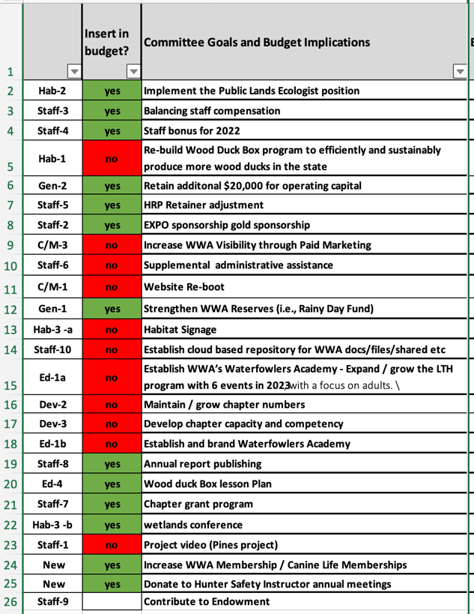
Bruce Ross asked the Board for a decision to either accept or reject the budget draft at the end of discussions. Adjustments from January’s BoD discussion were made. As presented, Bruce Ross highlighted that the FY/CY 2023 budget ends the year with a $30,000 deficit because the Board approved all expenditures presented in January. However, eleven budget items (displayed in red on the financial analysis presented) were not incorporated into the budget at this time. Bruce Ross noted that they can be included during the month of actual expenditure. Bruce Ross selected this approach because the budget items are not guaranteed expenses (i.e., the Pines property video, while discussed extensively in January, might not need to be funded by WWA as discussed during the Executive Director’s Update; similarly the WWA website make-over may or may not occur as originally discussed). Since WWA does not have a “Capital Budget” like larger business might have that segregate investment funds from their “Operating Budget;” WWA uses an all-inclusive Operating Budget. This mean expenditures as approved by the board last meeting increase expenses without an offsetting revenue, resulting in a negative projection by year’s end.
Shawn Gibbons asked for clarification regarding how “red” budget items get funded. Bruce Ross explained because the Board approved them in January’s budget discussion, a separate request to expend funds is not required and the monthly budget recap can simply note the expenditure.
Directors had no additional questions; Bruce Ross requested a vote to accept CY/FY 2023 Budget Draft 3 as WWA’s CY/FY 2023 Operating Budget. Shawn Gibbons motioned (Ian Bartelmez seconded) to accept CY/FY 2023 Budget Draft 3 as WWA’s CY/FY 2023 Operating Budget. The motion passed unanimously.
- 6:46 PM – Executive Director’s Updates (Executive Director Ross)
Wood Duck Box Update. As briefed last month, the Blackwell Job Corps Center in Laona will no longer make wood duck boxes for WWA because some boxes get sold to recuperate costs of non-donated materials. On 11 February a number of volunteers met at Dave Elwing’s house to cut out boxes from materials that Bruce Ross, Bruce Urben, and B.J. Grassmann retrieved from Laona. The team cut and wrapped kits or assembled a total of 113 boxes. The boxes will be transported to Bart Tegen in Rhinelander for online sales and shipping on 22 February.
The McNaughton Correctional Center (Lake Tomahawk) will build nesting boxes from this point forward at no cost to WWA. Additionally, McNaughton offers other inmate-made wood products to non-profits which can be used as event prizes. The Nicolet Area Chapter will transport the remaining WWA wood from Laona to Lake Tomahawk during the week of 20-24 February.
EXPO Update. The EXPO Steering Group met 9 February. EXPO 23 will be larger than its predecessors. There are already over $10,000 in sponsor commitments and more registered vendors. Additionally venue space is being rented and the Youth Conservation Congress plans to significantly expand the youth activities zone.
Pines Riverside Farms Project Video. As discussed in January, the Habitat Committee plans to create a project video capturing planning to completion of the Pines Riverside Farms wetlands enhancement. The video will be used to promote WWA and inform viewers of land use possibilities. On 10 February Travis Hamele (Scott Hamele’s cousin) contacted Bruce Ross and expressed an interest in producing the video in a joint effort between WWA and his company, United Country, a hunting realty company. Travis Hamele knows former Executive Director Jeff Nania and the Pines family. United Country offered to produce a high quality video of the project at no cost to WWA. United Country wishes to use the video as an example of what customers can do to improve their properties after being purchased.
Bruce Urben asked if WWA will have access to use the video when completed. Bruce Ross confirmed that WWA will be allowed unrestricted use of the video.
Shawn Gibbons suggested doing a presentation about the Pines Project at the EXPO.
Additional Funding Streams. Bruce Ross discussed an alternate funding stream target list compiled through the Development Committee. The list identifies existing and potential sources including grants, like-minded organizations, foundations, and various corporations. It will be posted on the Board webpage
Sustaining Sponsorships. Another Development Committee 2023 initiative is to increase the number of sustaining sponsors the organization has. Doing so provides a steady-stream funding flow that projects can be planned around. Russ Olson is creating a $20 per month ($240 annually) marketing flier. Bruce Urben urged all Directors to contribute a minimum of $20 per month towards this goal. Doing so can fund the part-time PLE position.

- 7:02 PM – Public Lands Initiative (Executive Director Ross)
Bruce Ross interviewed five Public Lands Ecologist (PLE) candidates and has made a verbal offer to Anthony Hatcher, to be followed up with a written offer. Bruce Ross relayed the he was confident that Anthony Hatcher will accept. He came to Wisconsin six months ago from Washington State where he worked private landowner voluntary actions, He moved to Wisconsin to be close to family, and he comes highly recommended by his former employer. Anthony’s anticipated start date is on/about 1 March. Anthony is relatively junior in experience, but brings CRP, Fields & Forests, and some wetlands restorations experience with him.
Bruce Ross discussed an opportunity to increase WWA’s PLE presence and influence by also hiring a more experienced part-time PLE. During the interviews Mark Pfost, a retired USFWS employee who lives near Necedah expressed interest in part-time employment. Because the PLE position has yet to be filled, two month’s budgeted salary has not been expended. Based upon having access to these funds, the desire to start on a very positive notes Mark Pfost’s 20+ years’ experience in public land management and scores of wetlands projects afford a quicker and more efficient start. Additionally, he can mentor Anthony Hatcher.
Year 1 funding for both positions fits within the approved budget when WWA’s increased overhead costs, anticipate corporate sponsorship, and the duck stamp grant (applied for) are figured into the mix. Year 2 funding requires WWA to identify roughly $4,800 of unforecasted funding. Initial plans are to source the delta through increased NAWCA, duck stamp and corporate sponsorships.
Ian Bartelmez asked if we overlapped WWA’s core mission areas with targets of opportunity by hiring two PLEs. Bruce Ross explained that the two positions will be geographically separated (Milwaukee & Necedah) to minimize overlap, however, initially until WDNR and WWA both get established and work processes get ironed out, there could be some unintended overlap. Ian Bartelmez further asked if we (WWA) were prepared to let one of the PLEs go if they fail to produce positive results. Bruce Ross explained that both positions are “At Will” positions, meaning that the employee can quit or WWA can fire him at any time. Productivity will be easy to track because both positions will need to submit detailed monthly project accountings which WWA will include as part of its monthly invoice to the WDNR.
Bruce Urben asserted that this is a great opportunity for WWA and that it comes with the potential to increase funds for the Association through the work being done and went on to say, “This is the biggest step to put more wetlands available to people in the state that WWA has ever undertaken.” Ian Bartelmez clarified that he has no doubt about the benefits being derived, he merely wanted to ensure that WWA would remain in control of the PLEs, to which Bruce Ross responded, “Absolutely; they will be WWA employees.”
Dave Elwing asked Bruce Ross if he (Bruce) thought that Mark Pfost’s USFWS experience could be leveraged to access federal funding. Bruce did not believe that Mark Pfost would directly influence any federal funding opportunities, but that Mark’s grant writing experience and knowing where to search for funding would benefit WWA.
Lastly, Bruce Urben noted that the WWA paid staff would almost be doubling in size and asked Bruce Ross if he had the capacity to manage the growing staff. Bruce Ross responded that he believes so. While Peter Ziegler cannot manage either of the PLEs, he can mentor Anthony, which will help greatly.
Pat Smith motioned (Dave Elwing seconded) a motion to approved increasing the budgeted 1.0 FTE Public Lands Ecologist position to 1.5 FTEs. The Board voted unanimously to proceed with 1.5 FTEs.
- 2:42 PM – Annual Meeting (Executive Director Ross)
Based upon Doodle poll responses there are still only seven directors available at any given time for an in-person Board meeting, and those dates are in April. Per Association By-Laws the annual meet (previously agreed to be offered as a virtual and in-person combination following the Board meeting) needs to be held during the first quarter (January through March). Conducting an annual meeting in April is not in compliance with Association By-Laws.
Russ Olson agreed that the Board could greatly benefit from an in-person meeting, but reminded the Board that members could meet in-person any month during the year. Kevin Banaszak offered the Newburg Sportsman’s Club as a low cost ($25.00 rental) option. Bruce Ross stated that we can still host a virtual Annual meeting during the first quarter (as required) and present personal awards to recipients during chapter events.
Kim Shady motioned (Ian Bartelmez seconded) that the Annual meeting be changed from an in-person to a virtual meeting. The Board unanimously voted in favor of holding a virtual Annual meeting. Bruce Ross and the WWA Staff will prepare for a virtual Annual meeting to be conducted during March. Bruce offered his hunt club, Nee-Pe-Nauk near Montello, as a low cost and fun location for an in-person Board meeting.
- 7:40 – By-Law Revisions (Secretary Elwing)
December’s and January’s Director nominations and elections exposed several inconsistencies regarding the timing and voting procedures detailed within Association By-Laws. Additionally, during January’s Executive Committee meeting, the Executive Committee discussed incorporating annual Code of Ethics, Conflict of Interest, a Gift Policy declarations into Association By-Laws. Further, that these declarations should extend to all state-level committee members in addition to all Directors. Secretary Elwing drafted and presented revisions to the By-Laws as directed by the Executive Committee. Todd Schaller motioned (Jim Freck seconded) to accept the proposed By-Law modification as presented. The Board unanimously passed the By-Law revisions. President Urben asked Secretary Elwing to finalize the revisions and have them posted on the Association webpage.
- 7:50 PM – Committee Updates
Development Committee (Dave Elwing): As previously noted during the Executive Directors Updates, the Development committee is working to identify and contact alternate funding sources, as well as targeting increased Sustaining Sponsorships. Dave Elwing also reported initiating contact with several members interested in starting a chapter within the Marshfield area.
Education Committee (Todd Schaller): The Education Committee met last week and will be kicking off the R3 Grant roll-out soon.
Policy Committee (Bruce Ross): Over 500 WWA members responded to the recent WWA survey asking about when seasons should open, etc. Additionally, 60 respondents expressed an interest in volunteering to help support WWA. George Ermert will launch a second, similar survey on Facebook to increase exposure. George Ermert is developing a survey of new state legislators to gauge their outdoor and conservation knowledge. DU and Delt logos will appear on the survey to demonstrate a broader exposure in interest. Bruce Ross and Bruce Urben are scheduled to meet Secretary Payne next week to introduce WWA to him.
Habitat Committee (B.J. Grassmann): The PLE wood duck box updates were discussed previously. Traditional habitat projects saw a 50% increase in 2022 over 2021 resulting in approximately 220 wetland acres being saved. B.J. Grassmann reported that three more projects were approved during the most recent committee meeting. Dave Elwing asked in anybody was actively collecting habitat project pictures for the 2024 Raffle Calendar; B.J. made a note of the request and stated that photos are being taken.
Marketing Committee (Ian Bartelmez): Limited projects have been initiated because the committee was waiting on having an approved budget. Followership on Facebook and Instagram continues to grow. The committee will hammer out a monthly plan and report progress to the Board. George Ermert, Bruce Ross, Kelcy Boettcher, and Nathan Woelful will meet at the beginning of March to start a website review. Bruce Ross stated that every committee will have the opportunity to provide website input.
- 8:00 PM – President’s Recap/Action Items (President Urben)
President Bruce Urben recap of the Board’s agenda, action items, and decisions included:
- The Board approved January’s Minutes.
- The Board reviewed and accepted Budget Draft 3 and unanimously voted to accept it as WWA’s CY/FY 2023 Operating Budget.
- President Urben reminded all Director’s that their assistance is needed to look out and identify alternate funding sources.
- President Urben reiterated the expectation that all Directors become Sustaining Sponsors.
- Executive Director Ross provided a PLE update, and the Board unanimously agreed to fund 1.5 (vs 1.0) FTEs worth of PLEs.
- The Board voted to rescind its January decision to conduct an in-person Board Meeting followed by a virtual Annual meeting. A virtual Annual meeting will be held during March (date, time, and location remain TBD).
- The Board unanimously voted to accept the By-Laws revisions as presented during this meeting.
- 8:03 PM – Meeting Adjourned
Next BoD meeting will be a virtual meeting at 6:30PM on March 15th.

