Who is WWA?  The Wisconsin Waterfowl Association is a 501(c)(3), membership-based, non-profit organization, founded by hunters in 1984, acting exclusively in Wisconsin.  Our Mission Statement:  The purpose of the Association shall be to restore and conserve Wisconsin’s waterfowl and wetland resources; to educate state waterfowlers during their progression from natural resource consumer to steward; and to promote governmental policies that protect Wisconsin’s resources and promote the rights of citizens to hunt.  Wisconsin Waterfowl Association  P.O. Box 427, Wales, WI 53183; wisducks.org |  |  |  | Wisconsin Waterfowl Association  7th Annual Class Induction Ceremony  - Thursday, March 16, 2023  Sat
WWA Hall of Fame  The History…  In 2016, WWA’s Board of Directors wished to honor those that have gone above and beyond to create, enhance and/or further the mission of our Association. Later that year a motion was made, and unanimously passed, by the Board to create the Wisconsin Waterfowl Association Hall of Fame. The Hall of Fame is dedicated to the recognition of the outstanding WWA Members, Sponsors, Board of Directors and/or Staff who, through their exceptional service, educational and legislative input, high personal standards, dedicated principles and contributions, have thereby enriched the general welfare of WWA.  Please join us in welcoming the 7th Annual Class of the Wisconsin Waterfowl Association Hall of Fame. |  |  | Pat Bentley – Member  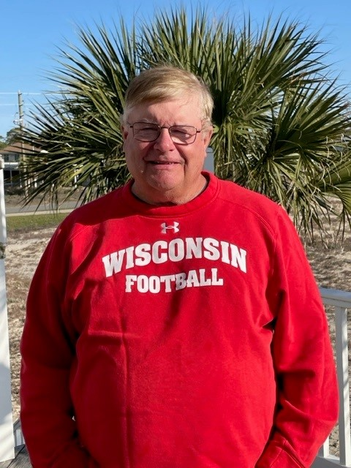  Pat lived close to the city of Princeton, Wisconsin, and having a family history of hunting he naturally became a duck hunter.  When Pat heard about WWA in the late 1980’s he joined and became a member of WWA. That membership developed into a long time of service to WWA, both for Pat and for his family.  Pat is what no one else can be in WWA: he is the FIRST person to receive the WWA Volunteer of the Year Award. Pat WAS the Princeton banquet for years, tirelessly working to procure donations, giving back to the organization through donations, and running the banquets from start to finish.  Pat later joined the WWA Board of Directors, serving until his last term expired at the end of 2009. Pat worked during his tenure at getting the WWA name out to the public by working with news sources. As Pat looks out his back patio, he can look at what WWA can do to enhance waterfowl reflected in the wetland restoration in his own backyard.  As written by Loren Voss, former WWA Regional Director.

